22k-5195 Laiba Fatima
SCD Lab 4
Task 1
import javax.swing.*;
import java.awt.event.ActionEvent;
import java.awt.event.ActionListener;
public class task1 extends JFrame {
private JPanel registration;
public JTextField textField1;
public JTextField textField2;
private JTextField textField3;
private JTextField textField4;
private JPasswordField passwordField1;
private JPasswordField passwordField2;
private JButton registerButton;
private JTextField textField5;
private JTextField textField6;
private JComboBox comboBox1;
public task1() {
registerButton.addActionListener(new ActionListener() {
@Override
public void actionPerformed(ActionEvent e) {
if (textField1.getText().isEmpty() || textField2.getText().isEmpty() ||
textField3.getText().isEmpty() || textField4.getText().isEmpty() || passwordField1.getText().isEmpty()
|| passwordField2.getText().isEmpty() || textField5.getText().isEmpty() ||
textField6.getText().isEmpty() || comboBox1.getSelectedItem() == null ) {
JOptionPane.showMessageDialog(registerButton, "All fields must be filled out.");
}
else{
if ( (passwordField1.getText().equals(passwordField2.getText()))){
dispose();
String selectedValue = (String) comboBox1.getSelectedItem();
new display(textField1.getText(), textField2.getText(), textField3.getText(), textField4.getText(), selectedValue,
textField5.getText(),textField6.getText());
}
else{
JOptionPane.showMessageDialog(registerButton, "Passwords don't match");
}
}
}
});
}
public static void main (String[]args){
task1 f1 = new task1();
f1.setContentPane(f1.registration);
f1.setTitle("User Registration");
f1.setSize(300, 300);
f1.setVisible(true);
f1.setDefaultCloseOperation(JFrame.EXIT_ON_CLOSE);
}
}

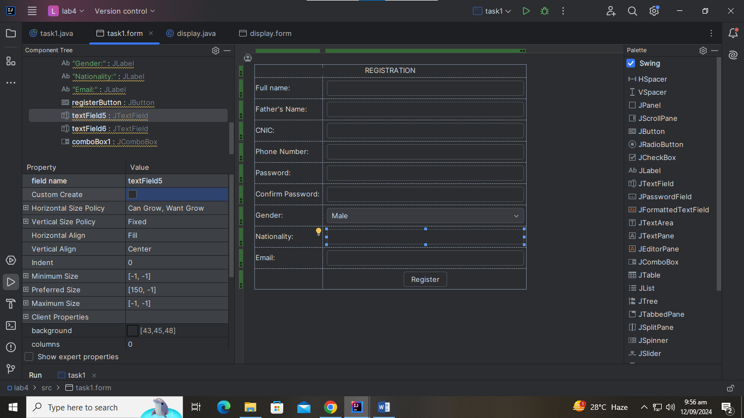
import javax.swing.*;
public class display extends JFrame {
private JPanel display;
private JTextArea textArea1;
public display(String name, String father, String cnic, String phone, String gender, String nationality, String email){
setContentPane(display);
setTitle("Display Details");
setSize(300, 300);
setVisible(true);
setLocationRelativeTo(null);
setDefaultCloseOperation(JFrame.EXIT_ON_CLOSE);
textArea1.setText("Name: " +name+"\nFather's Name: " +father+"\nCNIC: " +cnic+"\nPhone: " +phone+"\nGender " +gender+
"\nNationality: " +nationality +"\nEmail: " +email);
}
}
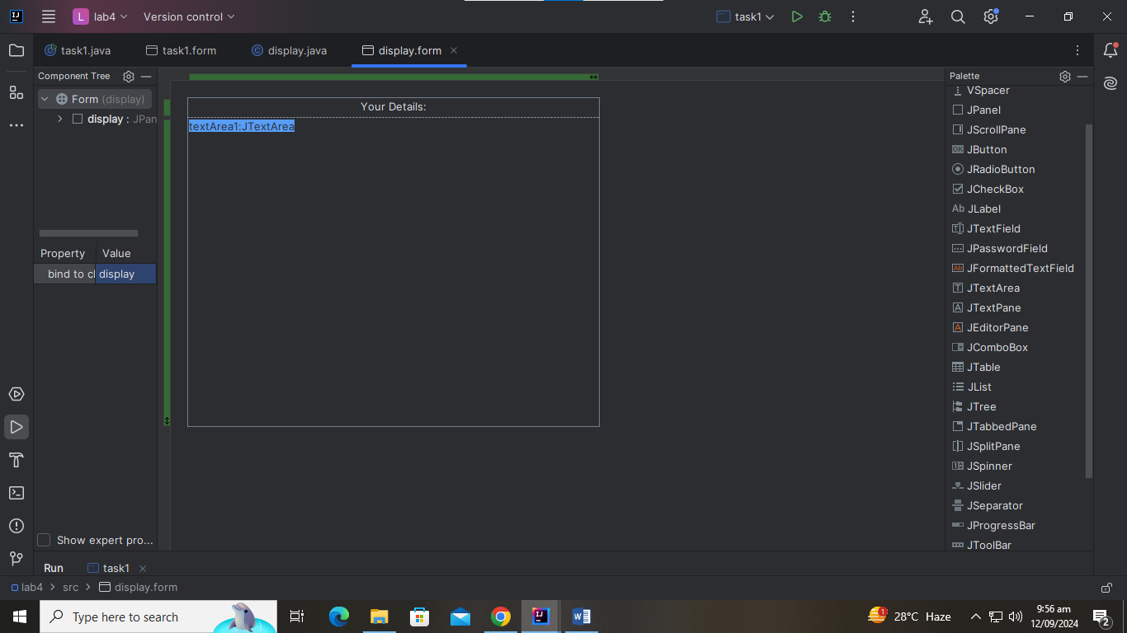
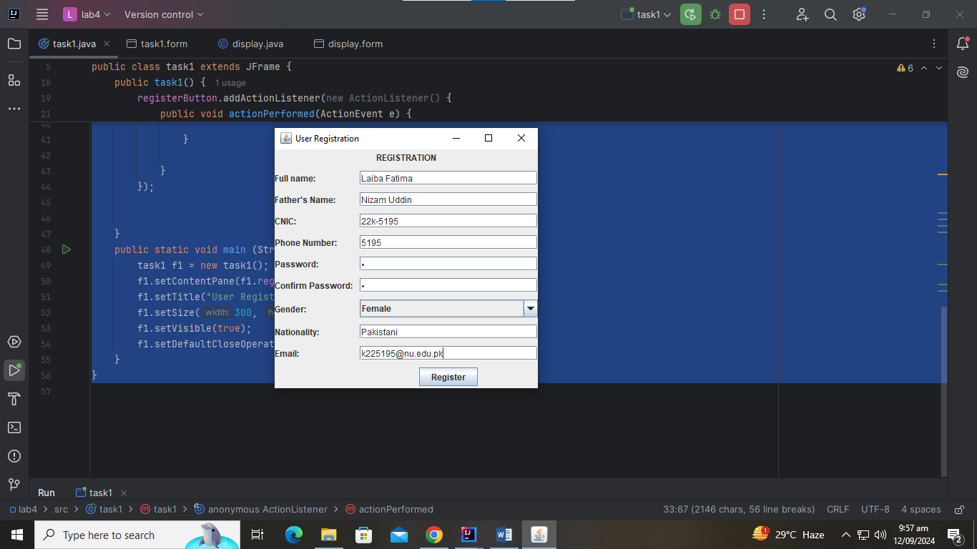
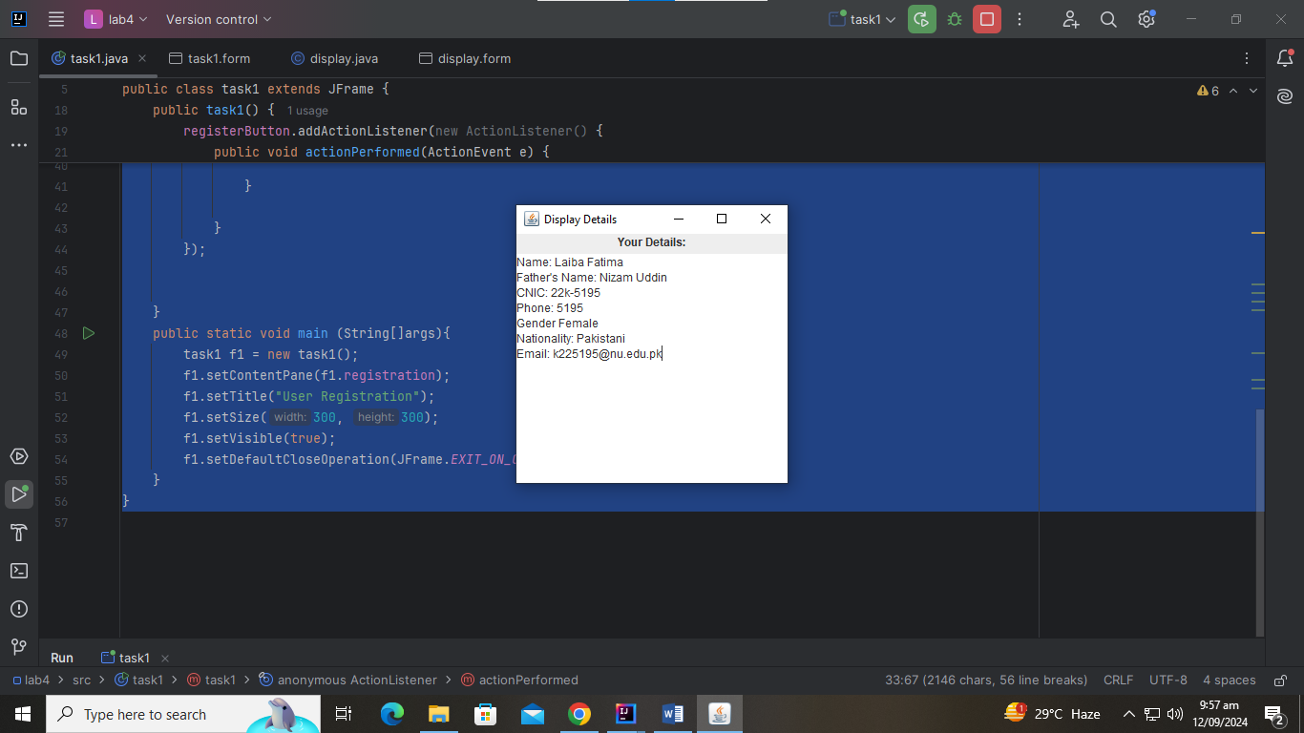
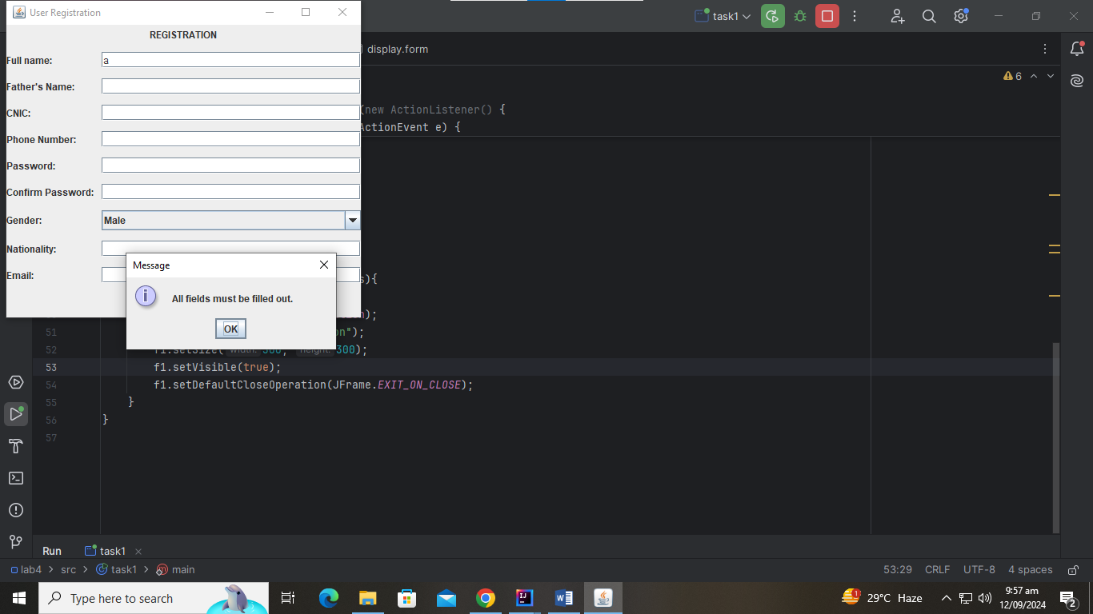
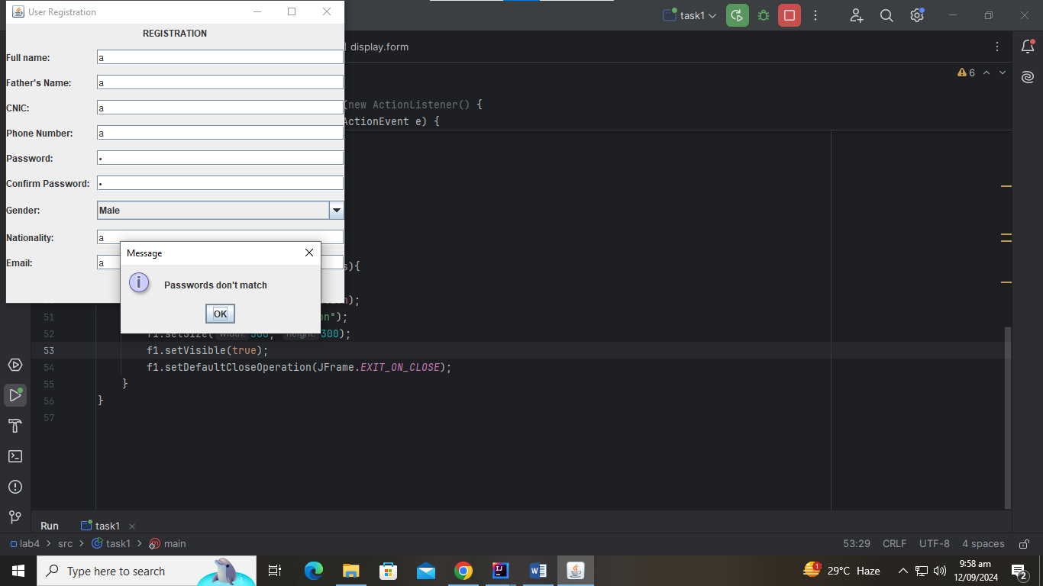
Task 2
import javax.swing.*;
import java.awt.event.KeyAdapter;
import java.awt.event.KeyEvent;
public class task2 extends JFrame{
private JPanel KeyboardEvent;
private JTextField textField1;
private JTextArea textArea1;
public task2() {
textField1.addKeyListener(new KeyAdapter() {
@Override
public void keyPressed(KeyEvent e) {
super.keyPressed(e);
char key = e.getKeyChar();
int ascii = e.getKeyCode();
if ( ascii == 16 || ascii == 17 ||ascii == 18 ||ascii == 10||ascii == 8){
}
else{
textArea1.setText("Key presses " +key +"\nASCII codes: " + ascii);
}
}
});
}
public static void main(String[] args) {
task2 event = new task2();
event.setContentPane(event.KeyboardEvent);
event.setTitle("22k-5195 Laiba ");
event.setSize(300,300);
event.setDefaultCloseOperation(JFrame.EXIT_ON_CLOSE);
event.setLocationRelativeTo(null);
event.setVisible(true);
}
}

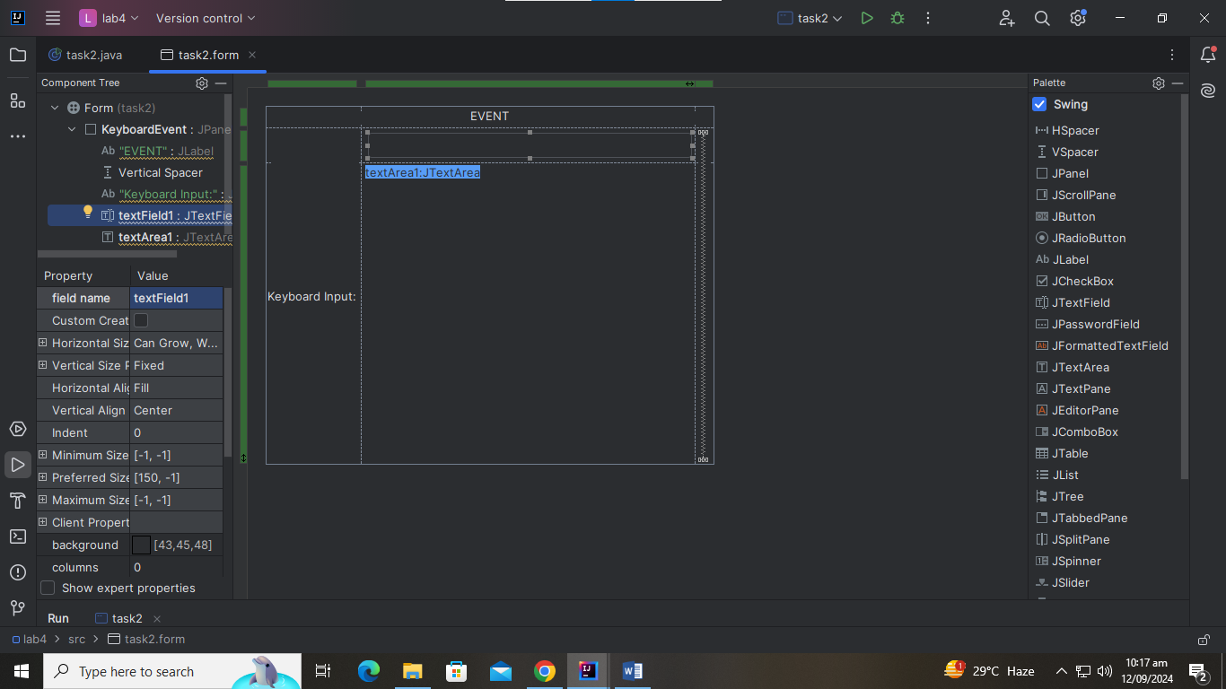
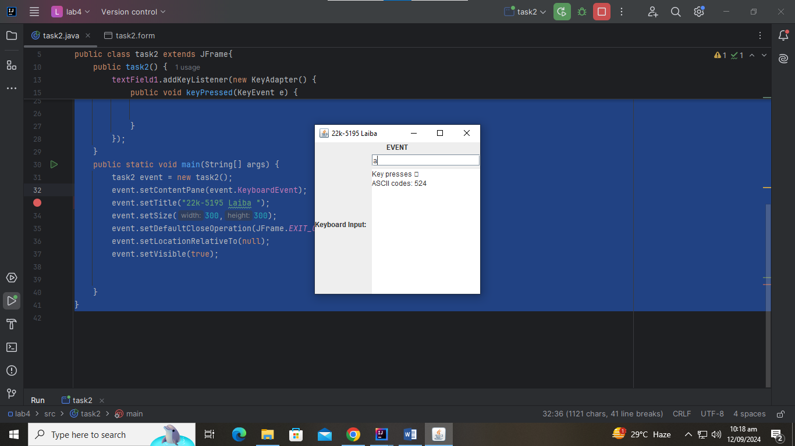
Task 3
import javax.swing.*;
import java.awt.event.ActionEvent;
import java.awt.event.ActionListener;

public class task3 extends JFrame{
private JPanel login;
private JTextField textField1;
private JPasswordField passwordField1;
private JButton signInButton;
String username = "22k-5195";
String password = "a";

public task3() {
setContentPane(login);
setTitle("ATM machine");
setSize(300,300);
setVisible(true);
setDefaultCloseOperation(JFrame.EXIT_ON_CLOSE);
signInButton.addActionListener(new ActionListener() {
@Override
public void actionPerformed(ActionEvent e) {
if ((textField1.getText().equals(username)) && passwordField1.getText().equals(password)){
dispose();
new MainMenu();
}
else{
JOptionPane.showMessageDialog(signInButton,"Invalid username or pin", "Login Failed!",JOptionPane.ERROR_MESSAGE);
}

}
});
}

public static void main(String[] args) {
task3 f1 = new task3();

}
}

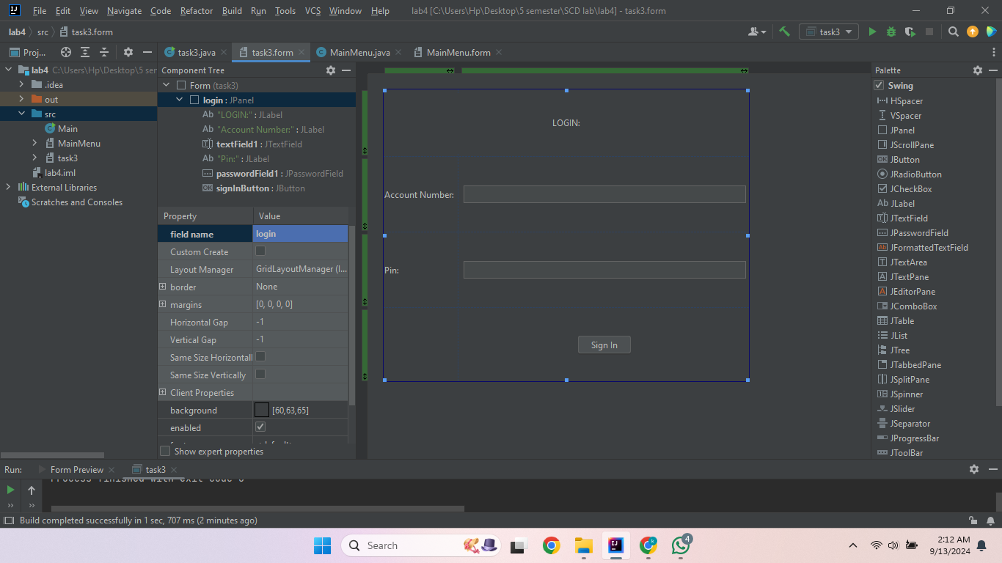
import javax.swing.*;
import java.awt.event.ActionEvent;
import java.awt.event.ActionListener;

public class MainMenu extends JFrame{
private JPanel mainmenu;
private JTabbedPane tabbedPane1;
private JTextField textField1;
private JButton logOutButton;
private JTextField textField2;
private JButton depositButton;
private JTextField textField3;
private JButton withdrawButton;

String balance = "20000";

public MainMenu() {
setContentPane(mainmenu);
setTitle("Main Menu:");
setSize(300, 300);
setVisible(true);
setLocationRelativeTo(null);
setDefaultCloseOperation(JFrame.EXIT_ON_CLOSE);
textField1.setEditable(false);
textField1.setText(balance);
logOutButton.addActionListener(new ActionListener() {
@Override
public void actionPerformed(ActionEvent e) {
dispose();
}
});
depositButton.addActionListener(new ActionListener() {
@Override
public void actionPerformed(ActionEvent e) {
int value1 = Integer.parseInt(textField1.getText());

int value2 = Integer.parseInt(textField2.getText());

if(value2 >0){
int value3= value1 + value2;
textField1.setText(String.valueOf(value3));
JOptionPane.showMessageDialog(depositButton, "Check Your Balance!", "Deposit Successsful!", JOptionPane.INFORMATION_MESSAGE);
textField2.setText("");
}
else{
JOptionPane.showMessageDialog(depositButton,"Input should be positive", "Invalid Input",JOptionPane.ERROR_MESSAGE);
textField2.setText("");
}
}
});
withdrawButton.addActionListener(new ActionListener() {
@Override
public void actionPerformed(ActionEvent e) {
int value1 = Integer.parseInt(textField1.getText());

int value2 = Integer.parseInt(textField3.getText());

if((value2 >0) && (value1 >value2)){
int value3= value1 - value2;
textField1.setText(String.valueOf(value3));
JOptionPane.showMessageDialog(withdrawButton, "Check Your Balance!", "Withdraw Successful!", JOptionPane.INFORMATION_MESSAGE);
textField3.setText("");
}
if(value2 <0){
JOptionPane.showMessageDialog(withdrawButton,"Input should be positive", "Invalid Input",JOptionPane.ERROR_MESSAGE);
textField3.setText("");
}
if(value1 <value2){
JOptionPane.showMessageDialog(withdrawButton,"Insufficient Funds", "Withdraw Unsuccessful!",JOptionPane.ERROR_MESSAGE);
textField3.setText("");
}

}
});
}
}

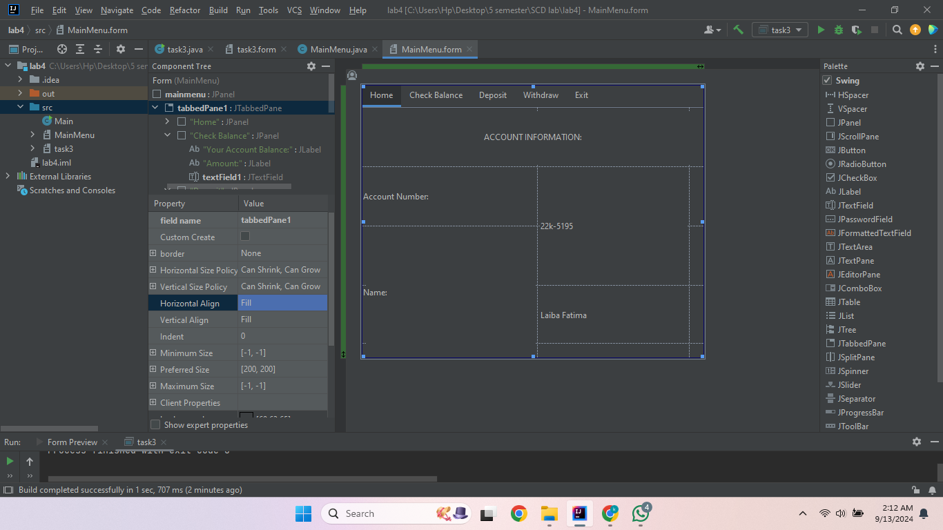
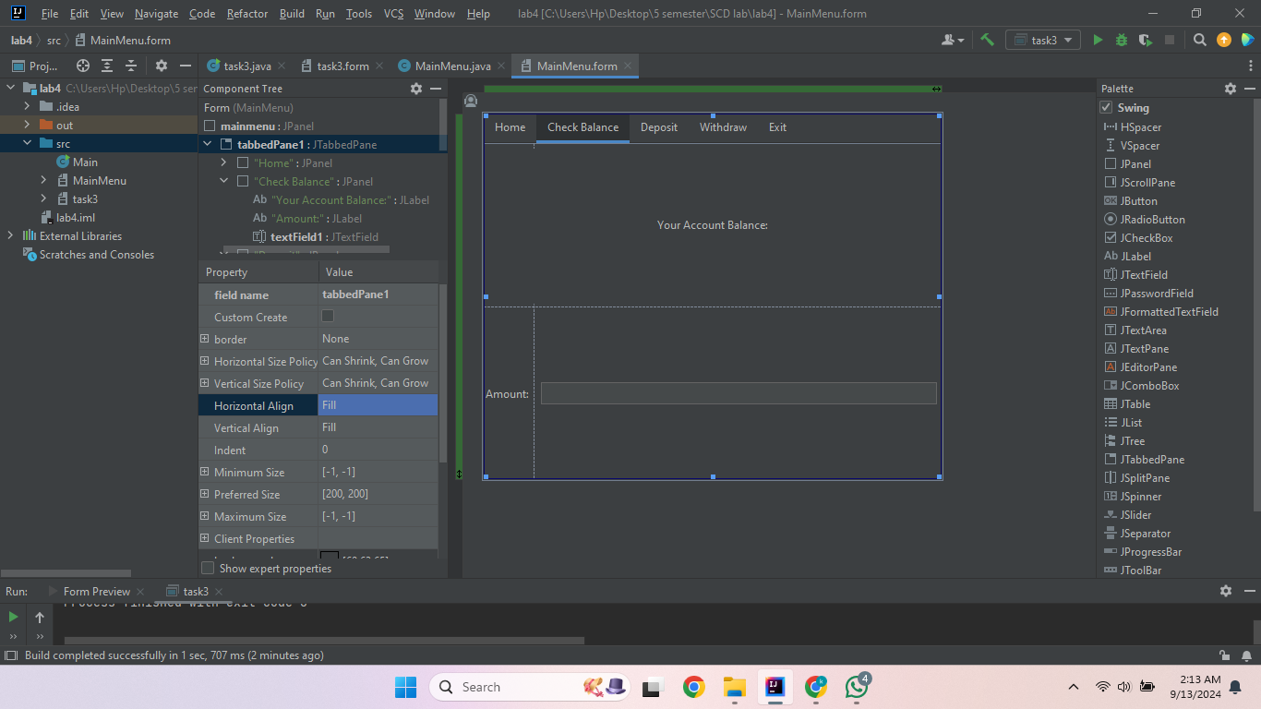
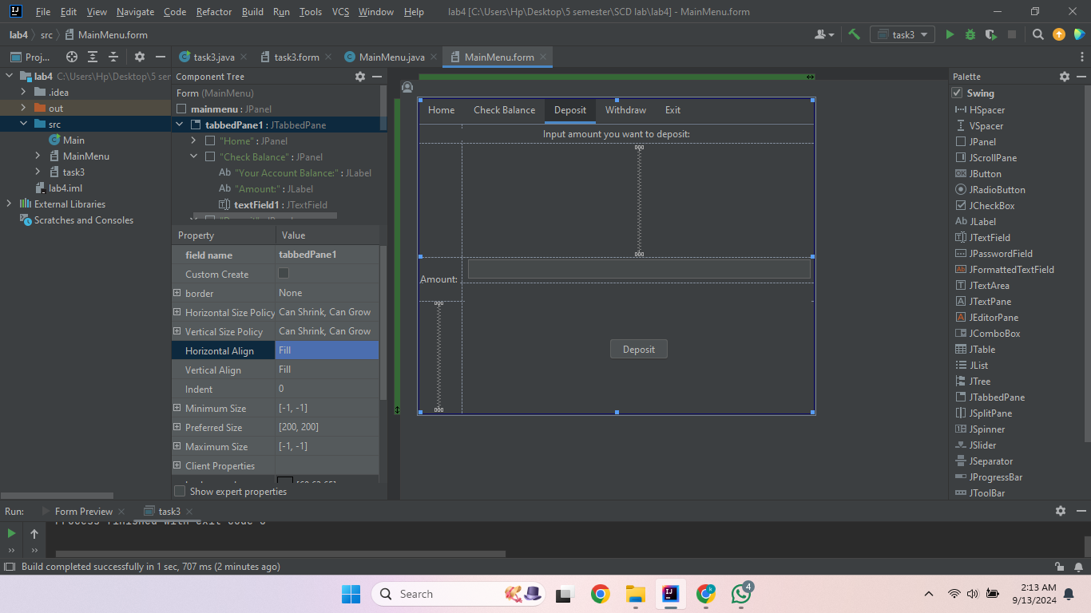
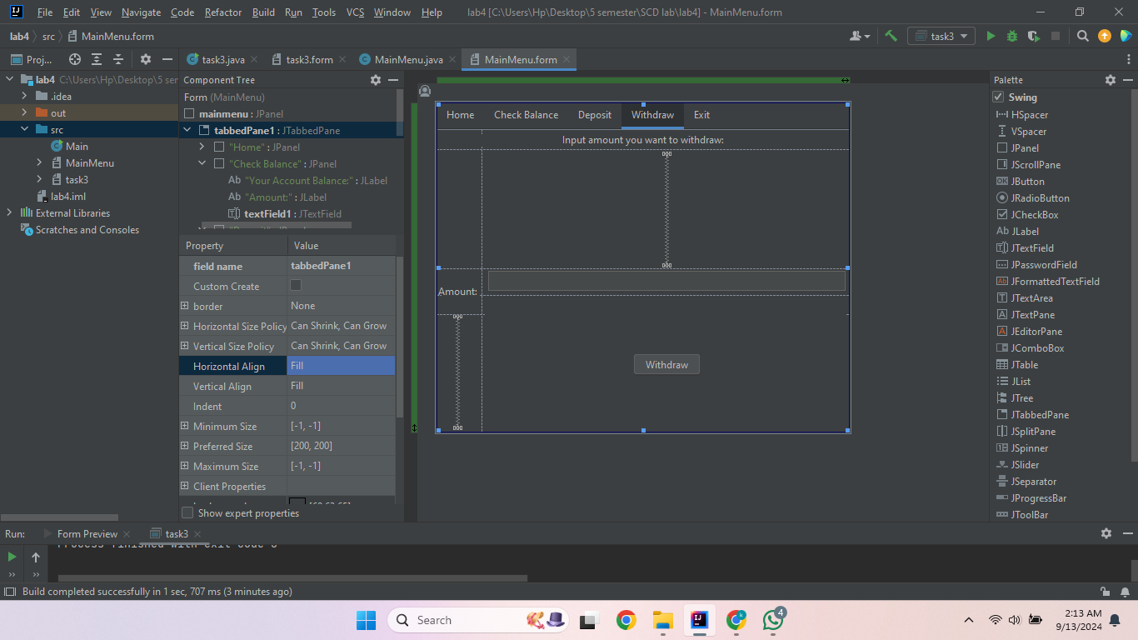
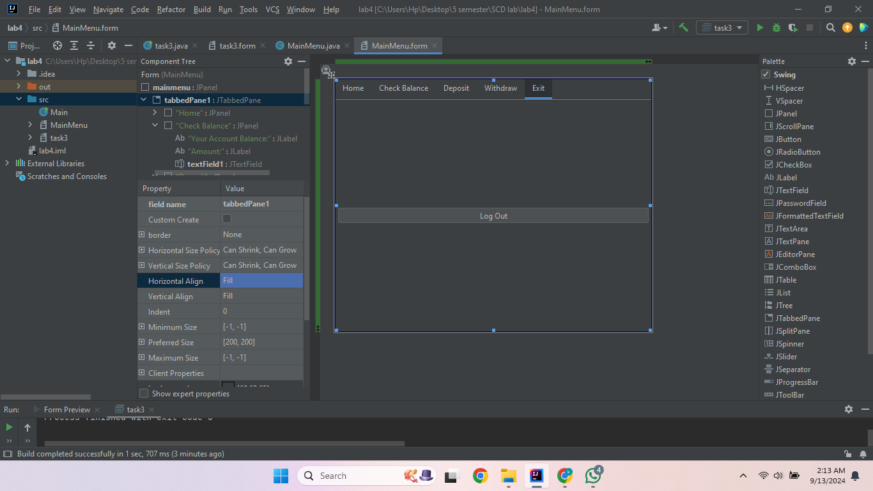
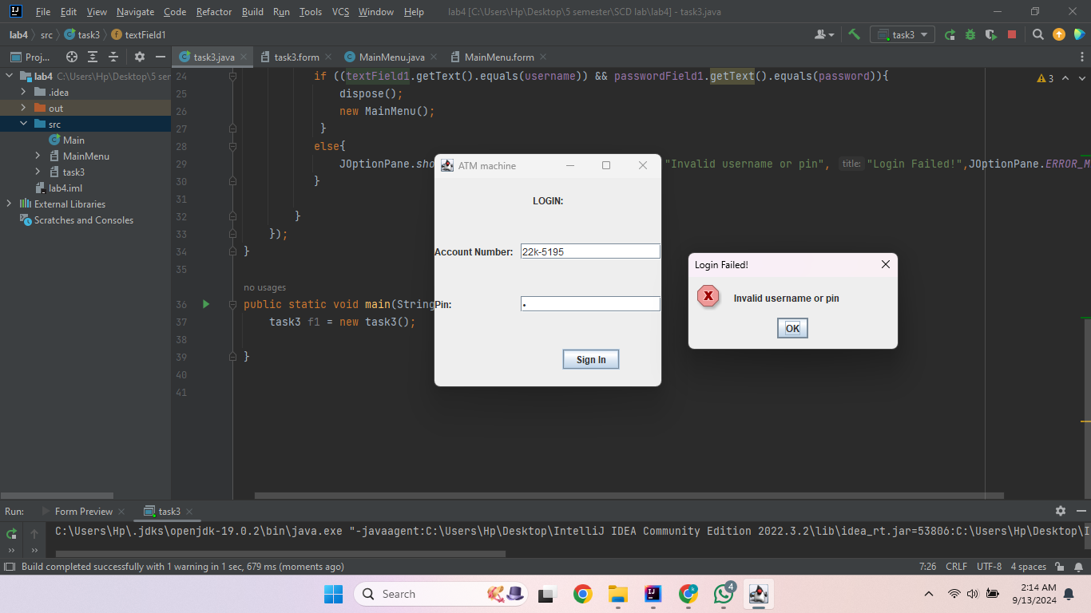
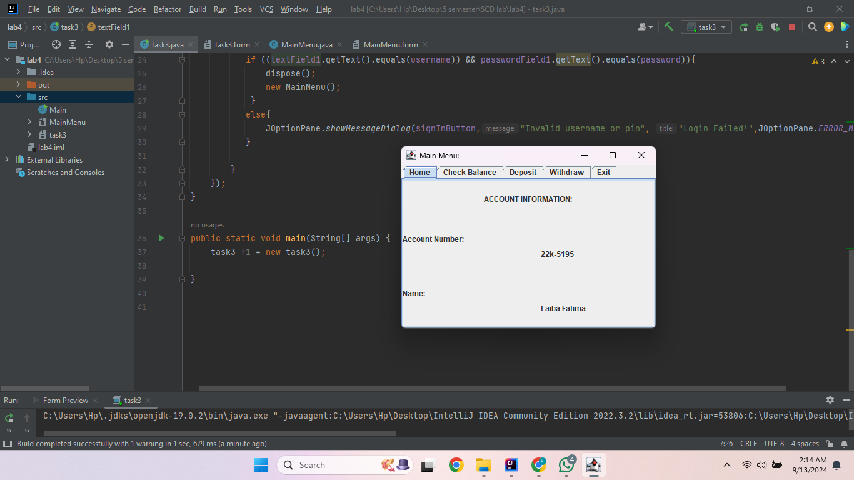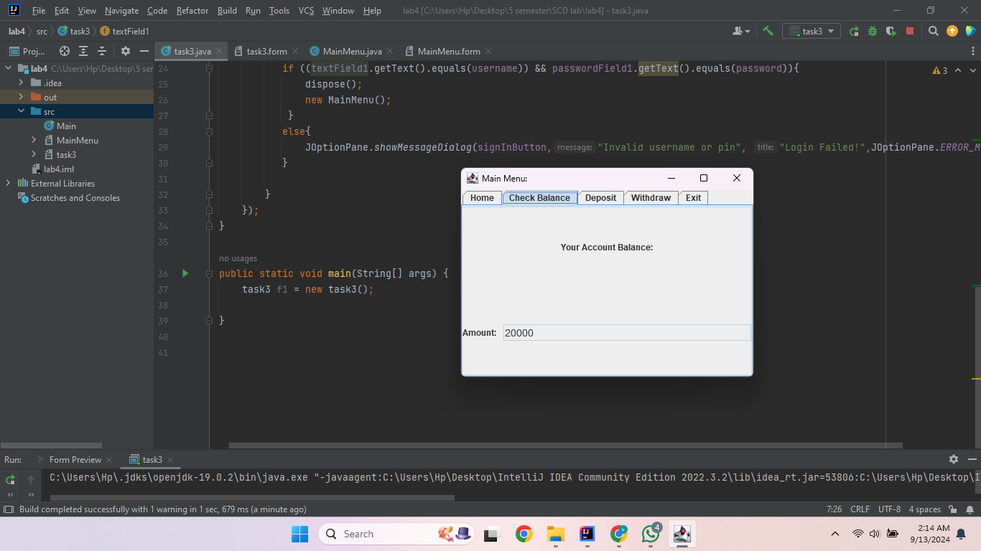
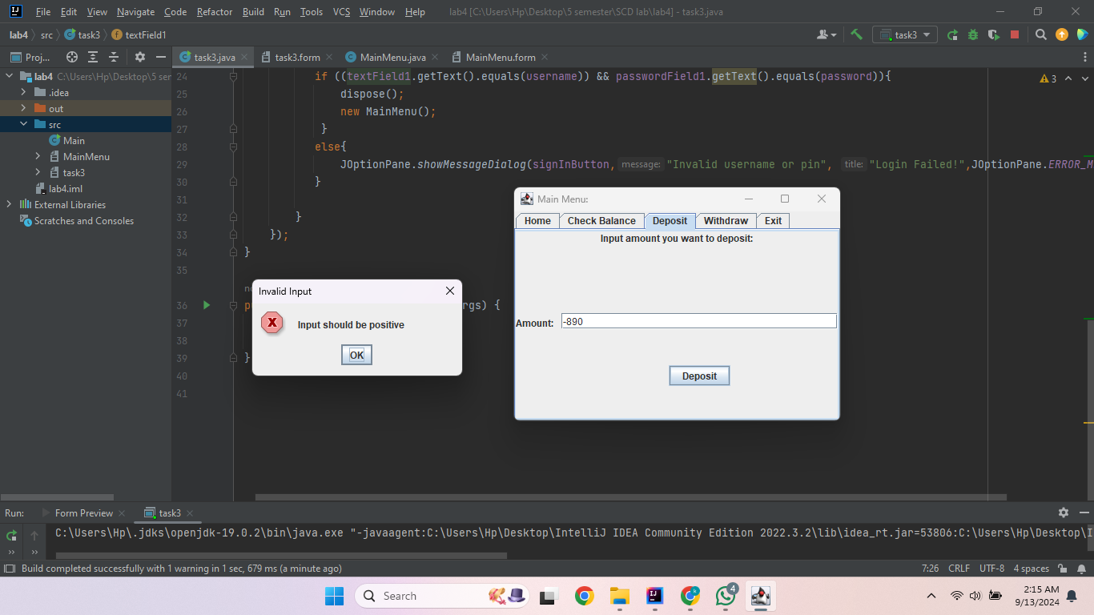
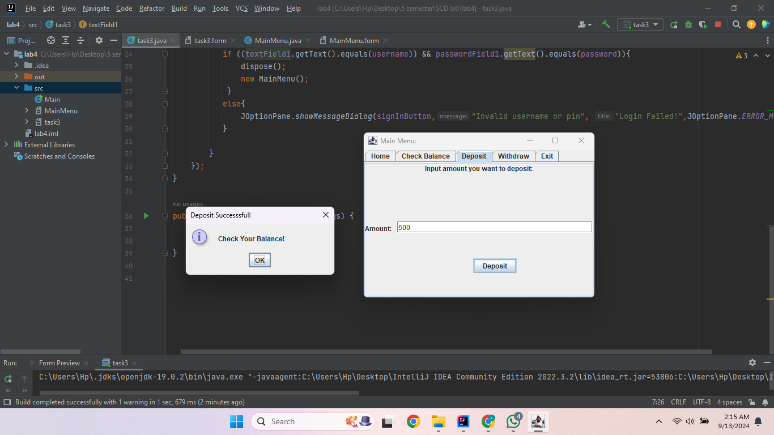
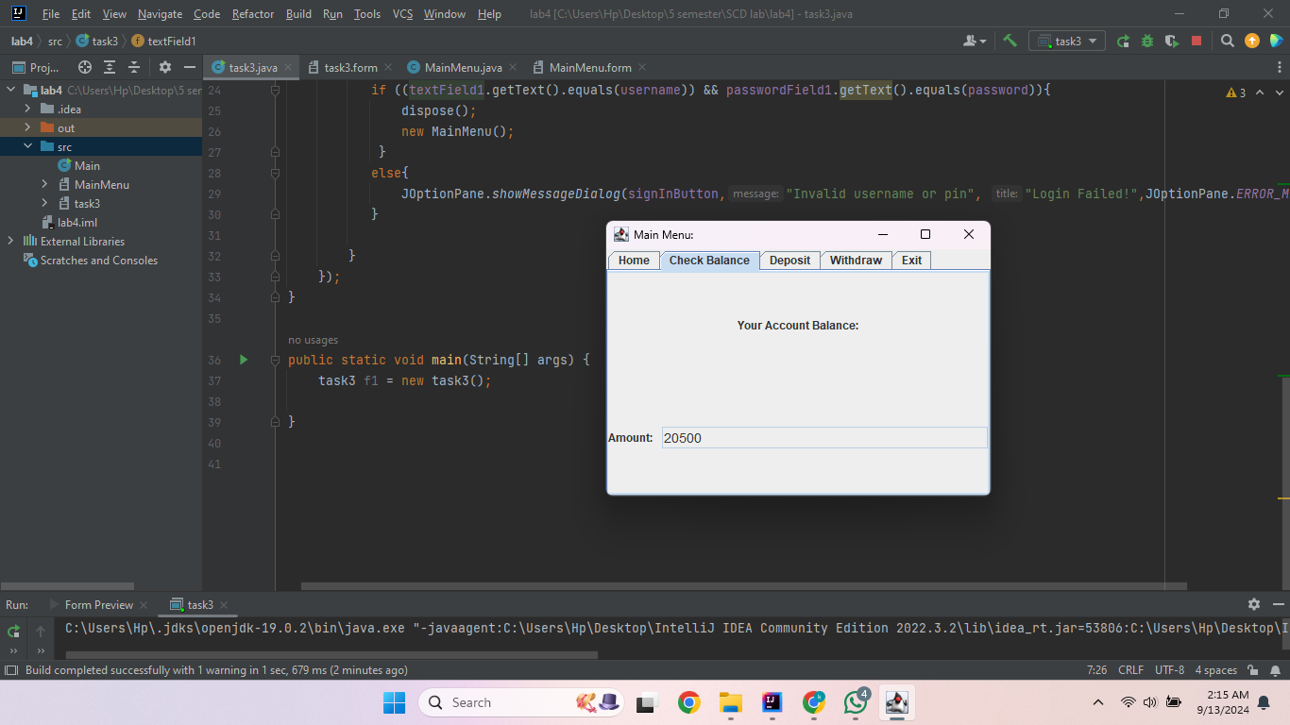
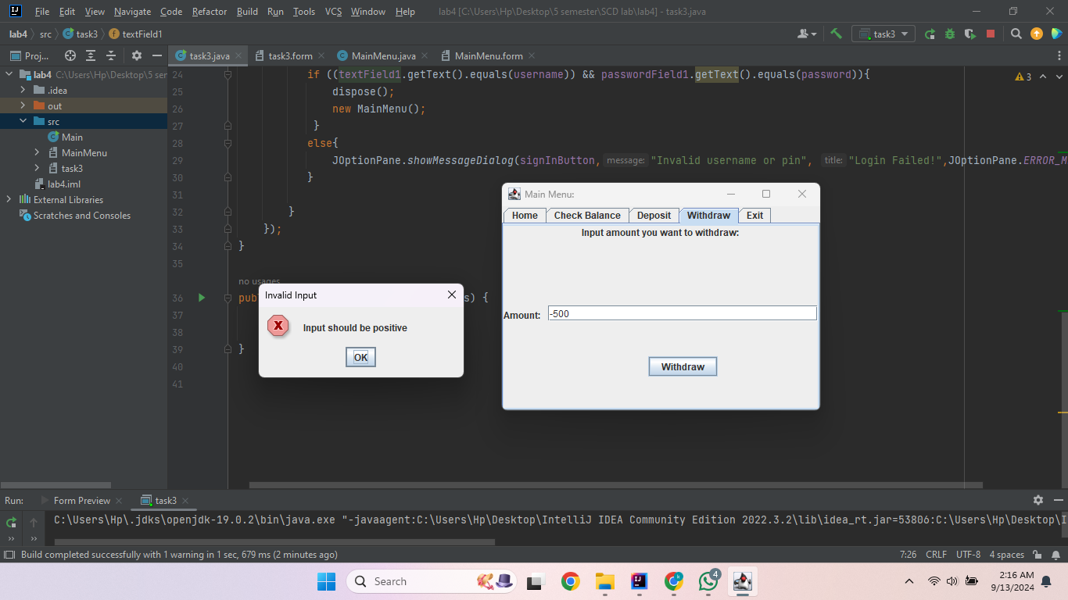
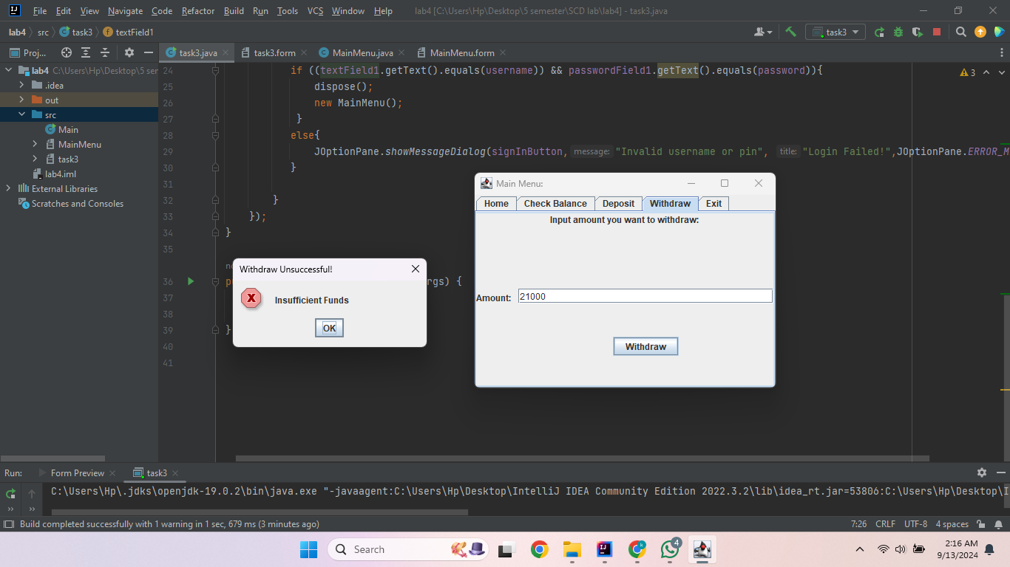
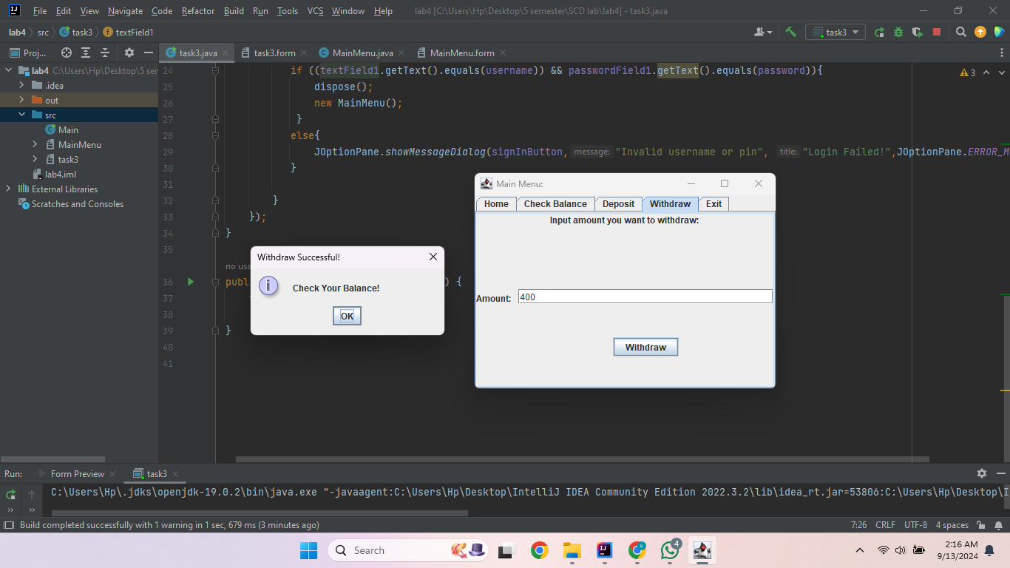
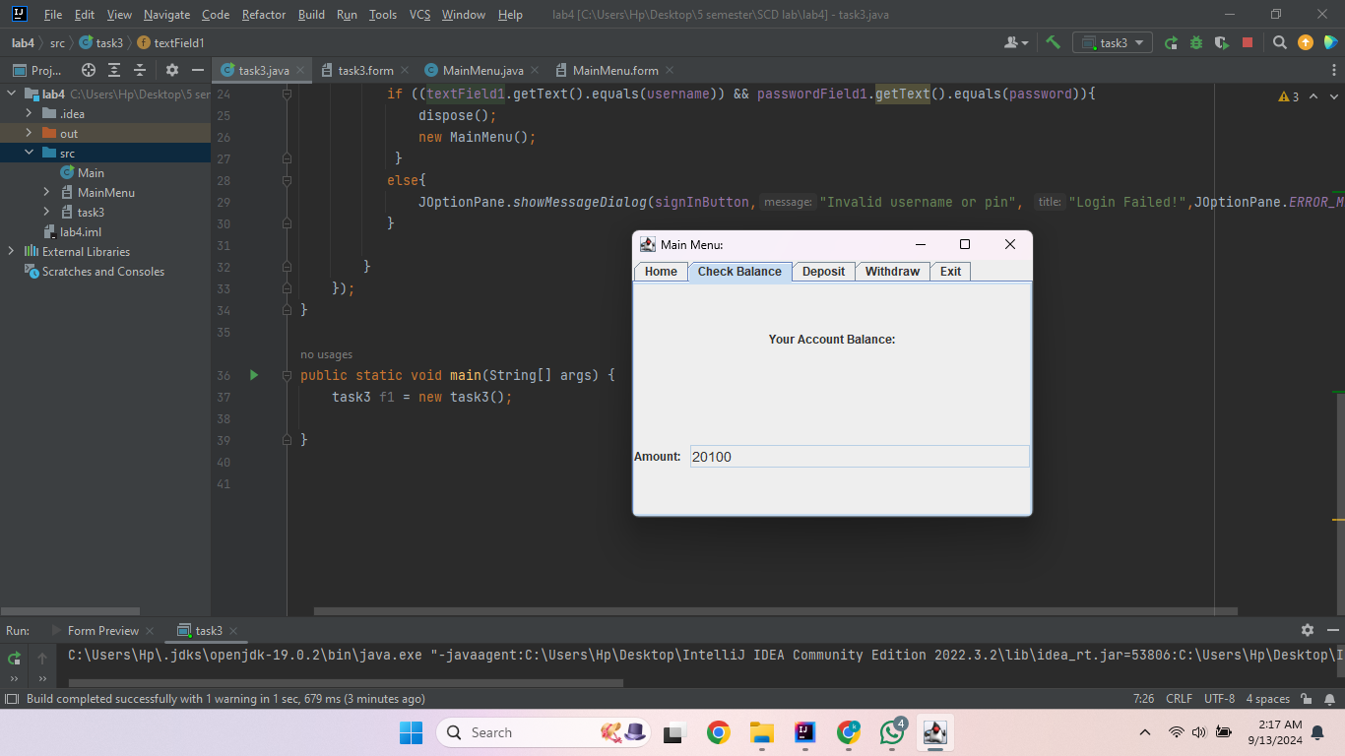
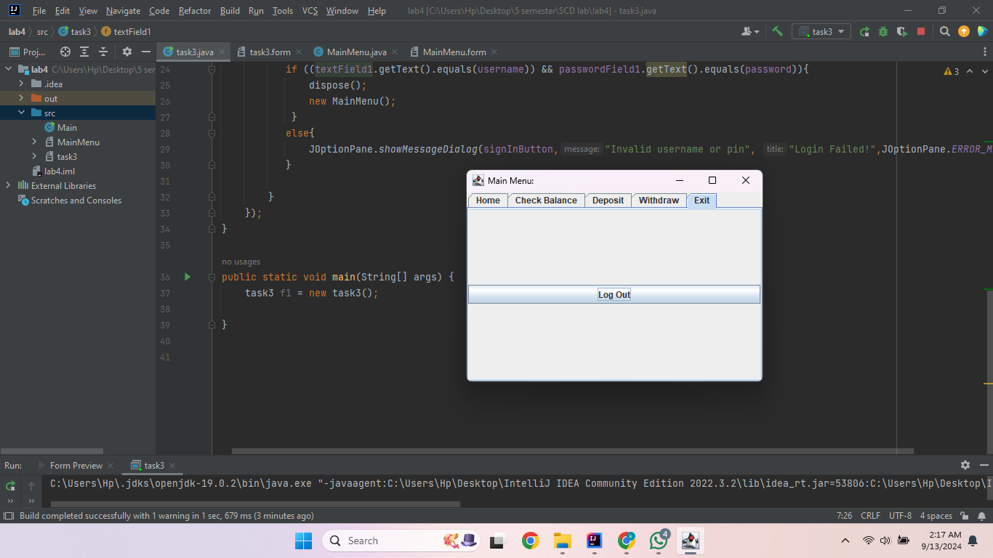
Task 4
import javax.swing.*;
import java.awt.event.ActionEvent;
import java.awt.event.ActionListener;

public class task4 extends JFrame {
private JPanel calculator;
private JTextField textField1;
private JTextField textField2;
private JTextField textField3;
private JTextField textField4;
private JTextField textField5;
private JTextField textField6;
private JTextField textField7;
private JTextField textField8;
private JTextField textField9;
private JTextField textField10;
private JTextField textField11;
private JTextField textField12;
private JButton calculateSGPAButton;
private JButton resetButton;

public task4() {
setContentPane(calculator);
setTitle("SGPA Calculator");
setSize(300,300);
setVisible(true);
setDefaultCloseOperation(JFrame.EXIT_ON_CLOSE);

calculateSGPAButton.addActionListener(new ActionListener() {

@Override
public void actionPerformed(ActionEvent e) {
if (textField1.getText().isEmpty() || textField2.getText().isEmpty() || textField3.getText().isEmpty() ||
textField4.getText().isEmpty() || textField5.getText().isEmpty() || textField6.getText().isEmpty() ||
textField7.getText().isEmpty() || textField8.getText().isEmpty() || textField9.getText().isEmpty() ||
textField10.getText().isEmpty() || textField11.getText().isEmpty() || textField12.getText().isEmpty()) {
JOptionPane.showMessageDialog(null, "All fields must be filled out.");

} else {
double sgpa = 0;
try {
int totalCreditHours = Integer.parseInt(textField6.getText()) + Integer.parseInt(textField9.getText()) +
Integer.parseInt(textField12.getText());
double totalPoints = (Double.parseDouble((textField5.getText())) * Integer.parseInt((textField6.getText()))) +
(Double.parseDouble((textField8.getText())) * Integer.parseInt((textField9.getText()))) +
(Double.parseDouble((textField11.getText())) * Integer.parseInt((textField12.getText())));
sgpa = totalPoints / totalCreditHours;

if (totalCreditHours == 0) {
throw new ArithmeticException();
}

} catch (NumberFormatException ex) {
JOptionPane.showMessageDialog(null, "Please enter valid numeric values for grades and credit" +
" hours.", "Invalid Input", JOptionPane.ERROR_MESSAGE);
} catch (ArithmeticException ex) {
JOptionPane.showMessageDialog(null, "Total credit hours cannot be zero.", "Error",
JOptionPane.ERROR_MESSAGE);
}

new sgpaform(textField4.getText(), Double.parseDouble((textField5.getText())), Integer.parseInt((textField6.getText())),
textField7.getText(), Double.parseDouble((textField8.getText())), Integer.parseInt((textField9.getText())),
textField10.getText(), Double.parseDouble((textField11.getText())), Integer.parseInt((textField12.getText())),
String.format("%.2f", sgpa));

}
}
});
resetButton.addActionListener(new ActionListener() {
@Override
public void actionPerformed(ActionEvent e) {

textField1.setText("");
textField2.setText("");
textField3.setText("");
textField4.setText("");
textField5.setText("");
textField6.setText("");
textField7.setText("");
textField8.setText("");
textField9.setText("");
textField10.setText("");
textField11.setText("");
textField12.setText("");
}
});
}

public static void main(String[] args) {
task4 f = new task4();
}
}

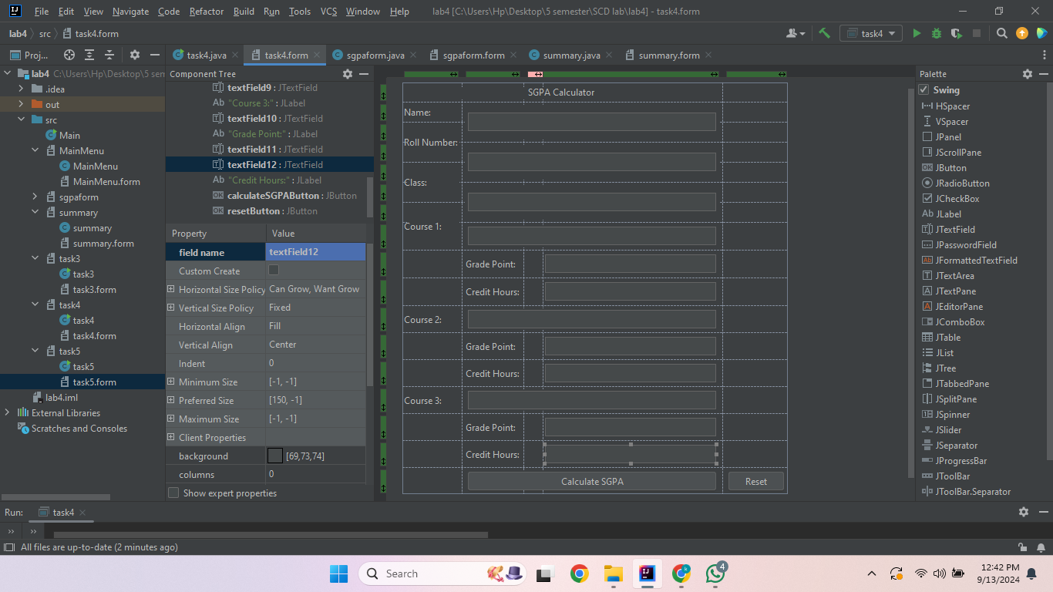
import javax.swing.*;
import java.awt.event.ActionEvent;
import java.awt.event.ActionListener;

public class sgpaform extends JFrame{
private JTextField textField1;
private JPanel display;
private JButton viewSummaryButton;

public sgpaform(String course1, double grade1, int creditHours1, String course2, double grade2, int creditHours2,
String course3, double grade3, int creditHours3,String value){
setContentPane(display);
setTitle("Calculated SGPA");
setSize(300,300);
setVisible(true);
setDefaultCloseOperation(JFrame.EXIT_ON_CLOSE);

String str = String.valueOf(value);
textField1.setText(str);
textField1.setEditable(false);

viewSummaryButton.addActionListener(new ActionListener() {
@Override
public void actionPerformed(ActionEvent e) {
new summary( course1, grade1, creditHours1, course2, grade2, creditHours2,
course3, grade3, creditHours3, value);
}
});
}
}

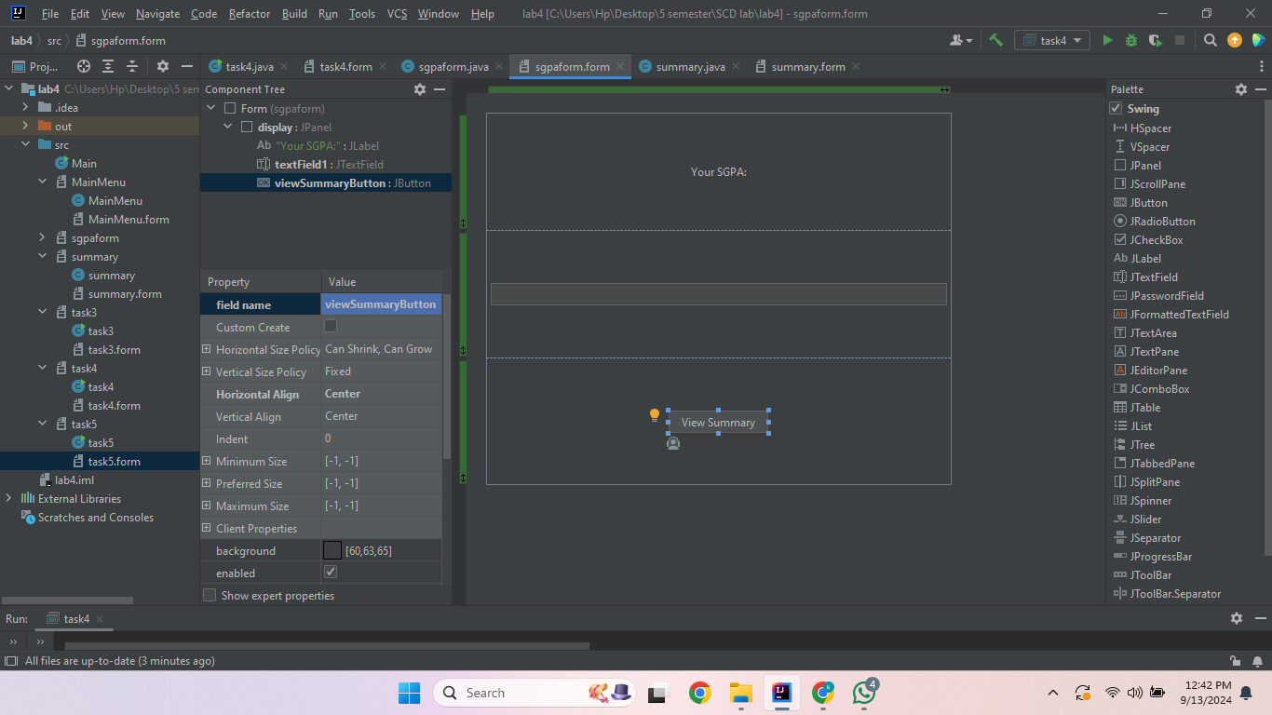
import javax.swing.*;

public class summary extends JFrame{
private JPanel summary;
private JTextField textField3;
private JTextField textField2;
private JTextField textField1;
private JTextField textField4;
private JTextField textField5;
private JTextField textField6;
private JTextField textField7;
private JTextField textField8;
private JTextField textField9;
private JTextField textField10;
private JTextField textField11;

public summary(String course1, double grade1, int creditHours1, String course2, double grade2, int creditHours2,
String course3, double grade3, int creditHours3,String value) {
setContentPane(summary);
setTitle("Summary Page");
setSize(300, 300);
setVisible(true);
setDefaultCloseOperation(JFrame.EXIT_ON_CLOSE);

textField1.setEditable(false);
textField2.setEditable(false);
textField3.setEditable(false);
textField4.setEditable(false);
textField5.setEditable(false);
textField6.setEditable(false);
textField7.setEditable(false);
textField8.setEditable(false);
textField9.setEditable(false);
textField10.setEditable(false);
textField11.setEditable(false);

textField1.setText(course1);
textField2.setText(String.valueOf(grade1));
textField3.setText(String.valueOf(creditHours1));
textField4.setText(course2);
textField5.setText(String.valueOf(grade2));
textField6.setText(String.valueOf(creditHours2));
textField7.setText(course3);
textField8.setText(String.valueOf(grade3));
textField9.setText(String.valueOf(creditHours3));
textField10.setText(String.valueOf(value));
if (Double.parseDouble(value) == 4) {
textField11.setText("Excellent");
} else if (Double.parseDouble(value) > 2 && Double.parseDouble(value) <4 ) {
textField11.setText("Good");
}
else{
textField11.setText("Needs Improvement");
}
}
}

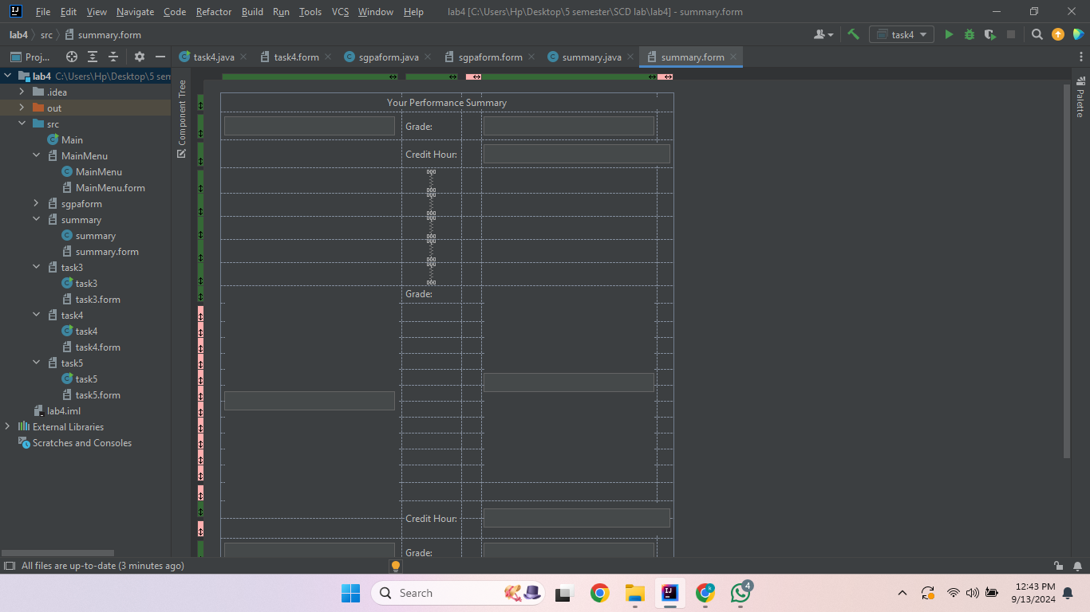
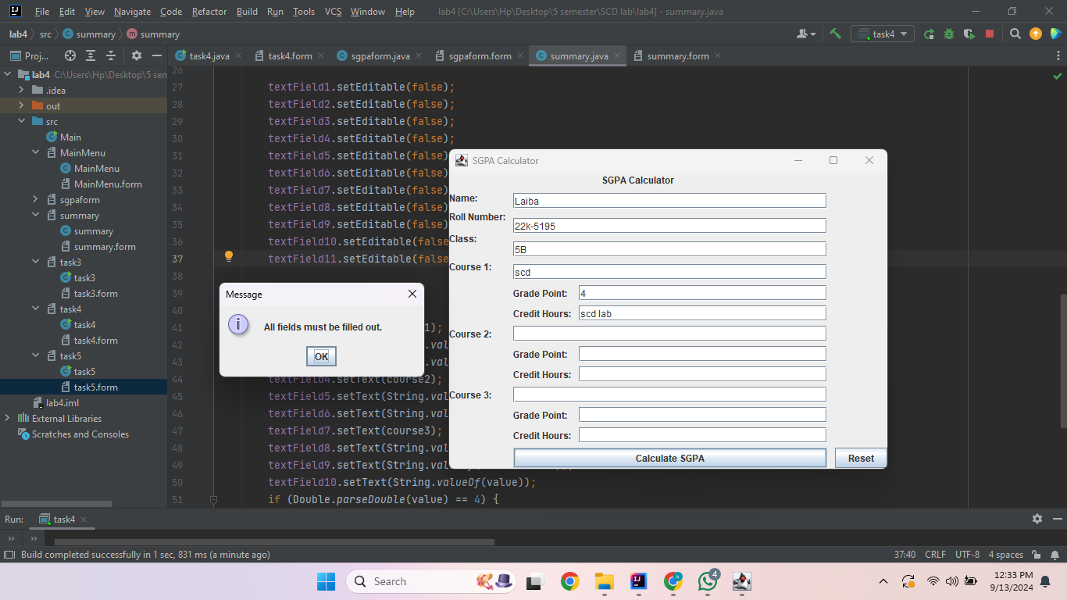
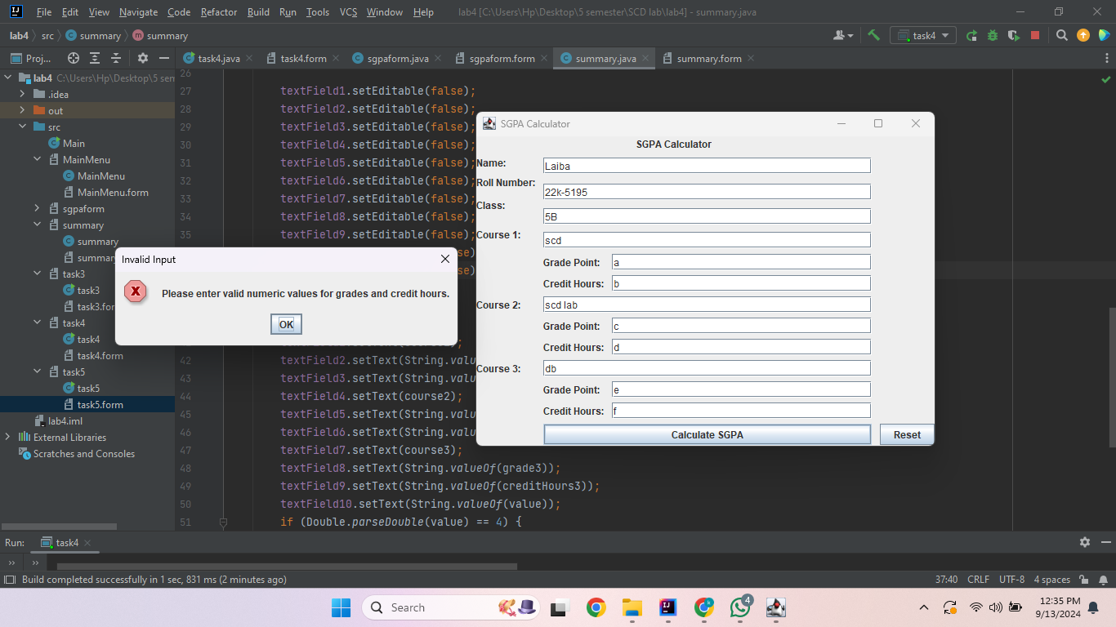
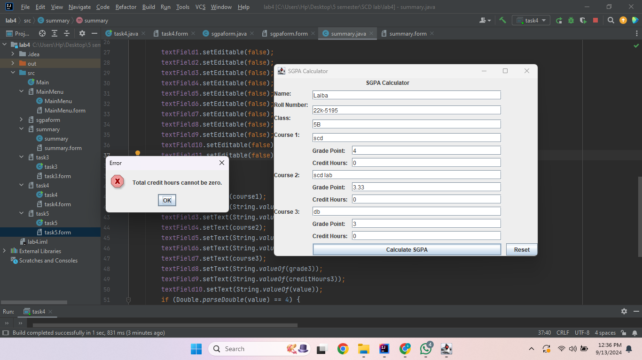
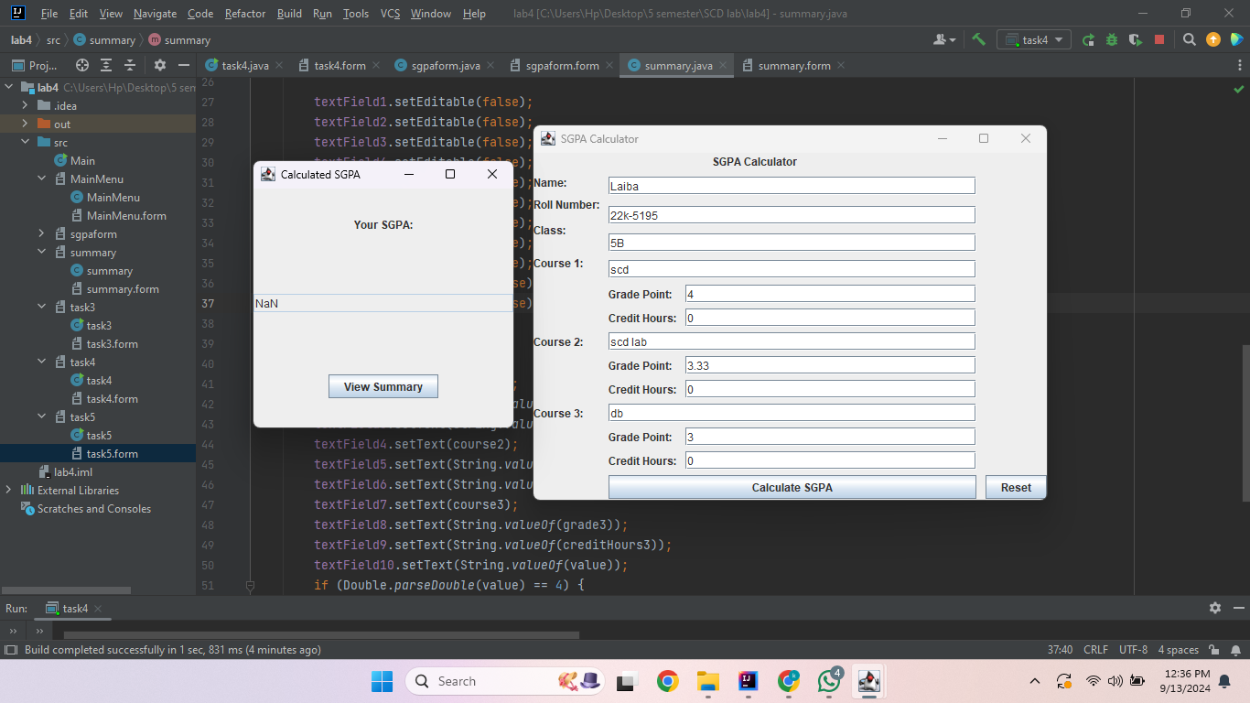
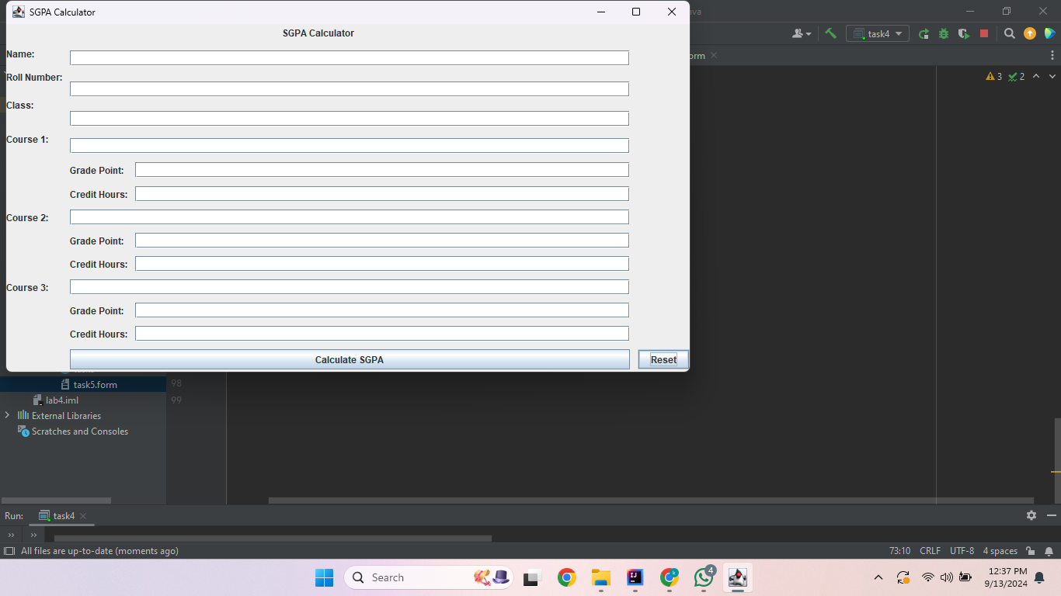
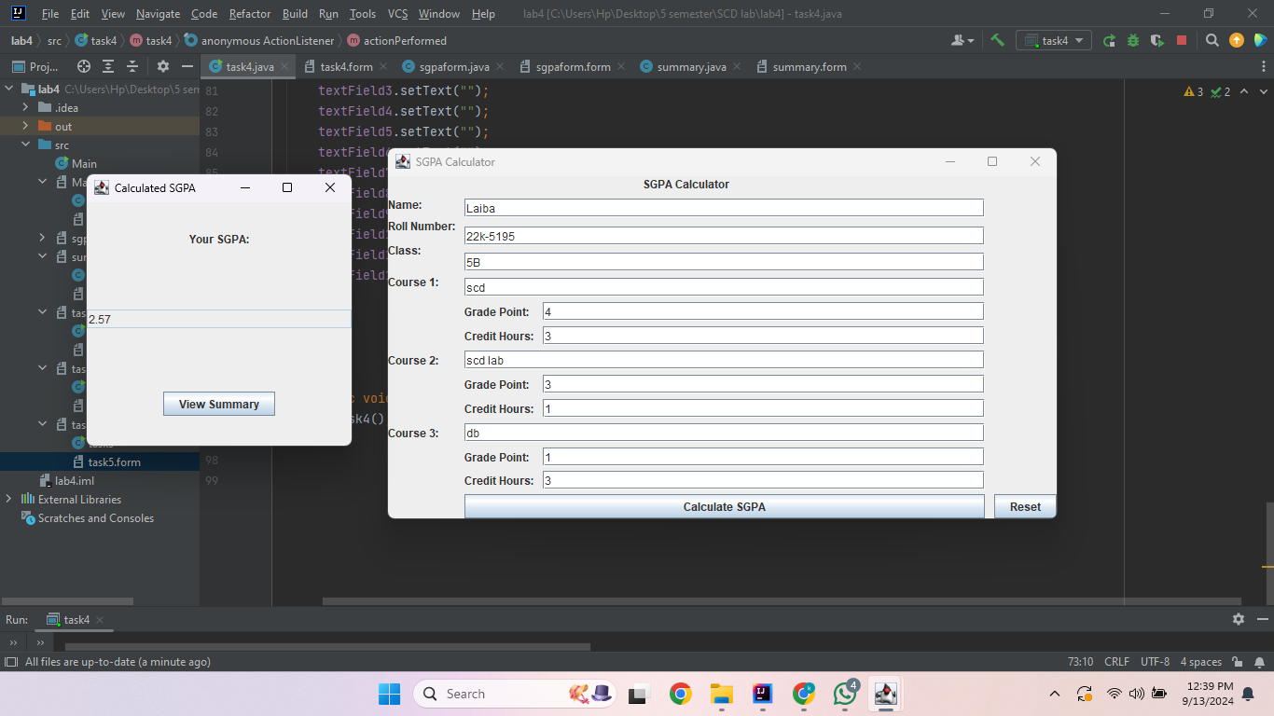
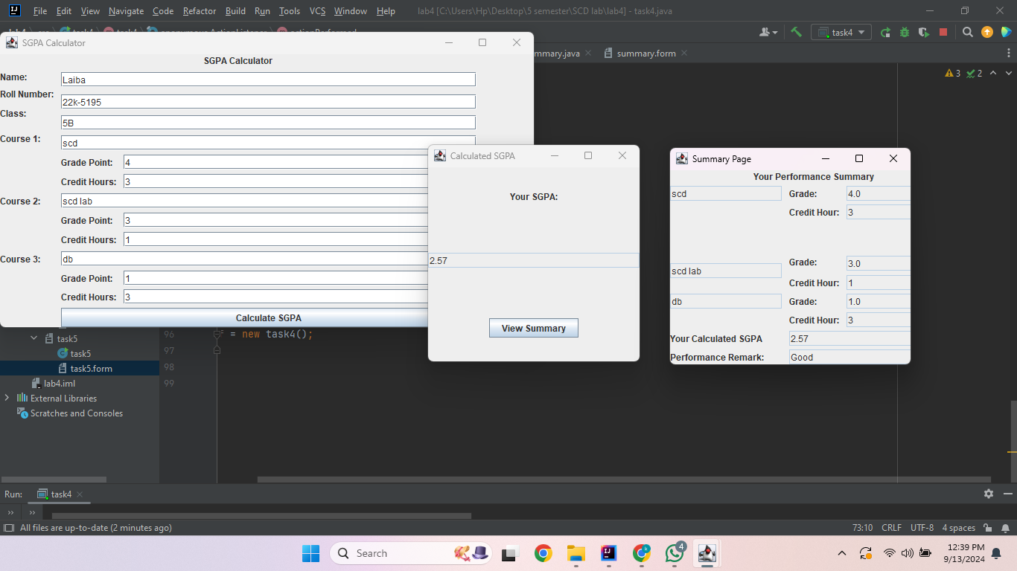
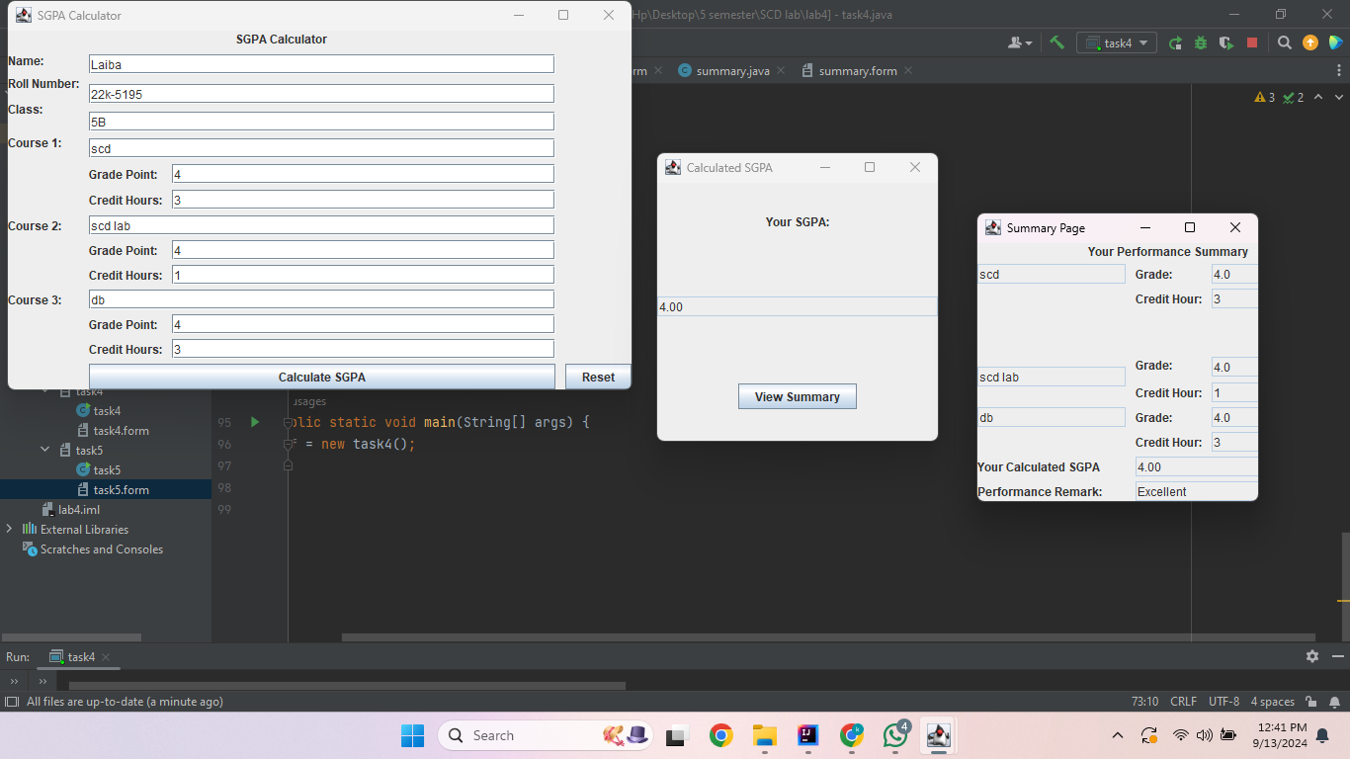
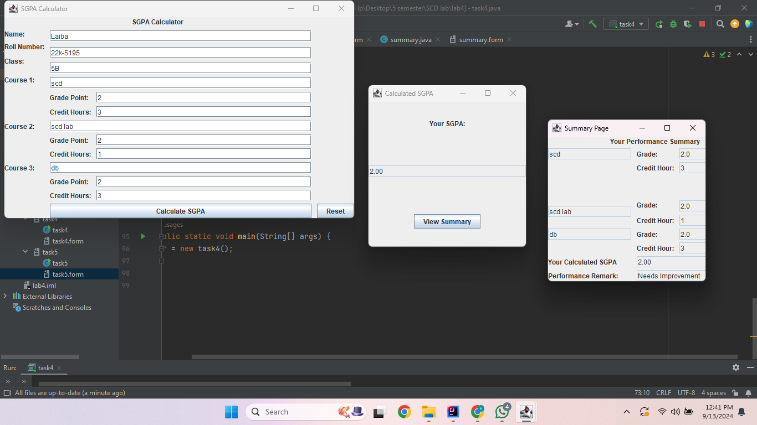
Task 5
import javax.swing.*;
import java.awt.event.ActionEvent;
import java.awt.event.ActionListener;
import java.awt.event.KeyAdapter;
import java.awt.event.KeyEvent;

public class task5 extends JFrame {
private JTextField textField1;
private JTextArea textArea1;
private JComboBox comboBox1;
private JButton transformButton;
private JPanel transform;
private JTextField textField2;

public task5() {
textArea1.setEditable(false);
transformButton.addActionListener(new ActionListener() {
@Override
public void actionPerformed(ActionEvent e) {
if (comboBox1.getSelectedItem().equals("Uppercase")) {
textArea1.setText(textField1.getText().toUpperCase());
} else if (comboBox1.getSelectedItem().equals("Reverse")) {
StringBuilder input1 = new StringBuilder();
input1.append(textField1.getText());
textArea1.setText(String.valueOf(input1.reverse()));
} else {
textArea1.setText(textField1.getText().replaceAll(" ", "_"));
}
}
});
textField2.addKeyListener(new KeyAdapter() {
@Override
public void keyReleased(KeyEvent e) {
super.keyReleased(e);
textField1.setText(textField2.getText());
textField1.setEditable(false);
}
});
}

public static void main(String[] args) {
task5 fr = new task5();
fr.setContentPane(fr.transform);
fr.setTitle("Real-Time ");
fr.setSize(300,300);
fr.setVisible(true);
fr.setDefaultCloseOperation(JFrame.EXIT_ON_CLOSE);
}
}

